Report
On
Smart note taker

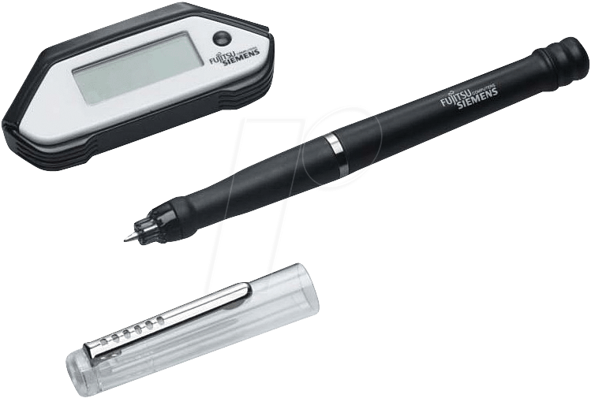
Submitted By:-
RISHABH ARYA
(13ecu106)
ELECTRONICS AND COMMUNICATION ENGINEERING
northcap UNIVERSITY
GURGAON

abstract

Smart Note Taker is a helpful product that satisfies the needs of the people in today's technologic and fast life. This product can be used in many ways. The Smart Note Taker provides taking fast and easy note making to people who are busy with one's self.
With the help of Smart Note Taker, people will be able to write notes in air, while being busy with their work. The written note will be stored in the memory chip of the pen, and will be able to read in digital medium after the job is done. This saves time and facilitate life.
This product is simple but powerful. It has the ability to sense 3D shapes and motions that the user tries to draw. The sensed information will be processed and transferred to the memory chip and then will be monitored on the display device. The shape that is drawn can be broadcasted to the network or sent to a mobile device.
INDEX

CONTENTS PAGENO
- Introduction - 04
1.1) Features of smart note take - 05

- System Overview - 06
2.1) Construction - 06
2.2) Technical definition of the product - 09
2.3) Opportunities in market - 09
2.3.1) Treats in the market - 10
2.4) Consumer profile and purchase power - 10
- Advantages - 11
- Current Products - 12
4.1) Mobile Note Taker - 12
4.2) PC Note Taker - 13
- Future Scope - 14
- Conclusion - 15
- References - 16
- FIGURES LIST

  - Smart Note Taker interior structure - 07
2.1.1 Working of a Smart Note Taker - 08
4.1 Mobile Note Taker - 12
4.2 PC Note Taker - 13
- INTRODUCTION

The Smart Note Taker a powerful tool that satisfies the needs of the people in today's technology and fast life. This product can be used in many ways. The Smart Note Taker provides fast and easy note making to people who are busy with oneself . With the help of Smart Note Taker, people will be able to write notes in air, while being busy with their work. The written note will be stored in the memory chip of the pen, and can be read in digital medium after the job is done. This saves time and facilitate life.

The Smart Note Taker is good and helpful for the blind who can’t see but can think and write freely. Another case, where our product can play an important role, is where two people talks on the phone. The subscribers are apart from each other during their conversation, and they may like to use figures or texts to make them themselves understand better.

It is also useful especially for the instructors during their presentations. The instructors may not want to present the lecture on the board. The figures can be processed and sent directly to the server computer in the room. The server computer then broadcasts the drawn shape through network to all of the computers which are present in the room. By this way, the lectures can be made to be more efficient and fun. This product may look simple but is powerful.

The product can also sense 3D shapes and motions that the user tries to draw. The sensed information will be processed and transferred to the memory chip and then will be monitored on the display device. The drawn shape then can be broadcasted to the network or sent to a mobile device.

There will be an additional feature of the product which will monitor the notes, which were taken before, on the application program used in the computer. This application program can be a word document or an image file.
Then, the sensed figures that were drawn onto the air will be recognized and by the help of the software program we write, the desired character will be printed in the word document.
If the application program is a paint related program, then the most similar shape will be chosen by the program and will be displayed on the screen.

1.1 Features of Smart Note Taker

- With the help of smart note taker handwritten notes can be instantly converted into editable text.
- It is good and helpful for blind who can’t see but think and write freely.
- Another place, where our product can play an important role is where two people talk on the phone. The subscribers are apart from each other while their talk, and they may want to use figures or texts to understand themselves better.
- It is also useful, especially for instructors during their presentations. The Instructors may not want to present the lecture on the board. The figure can be processed and can be sent directly to the server computer in the room. The server computer then broadcasts the drawn shape through network to all of the computers which are present in the room. By this way lectures be made to be more efficient and fun.
- It can recognize upto 22 Languages such as English – Canada , English - GB, English-US ,German, Simplified Chinese, Traditional Chinese ,Korean, Danish, Spanish, Spanish-Mexico, Finnish, French, French-Canada, Greek, Italian, Japanese, Dutch, Norwegian, Portuguese, Portuguese-Brazil, Russian, Swedish.
- Highly portable pen - 135 x 14,5 mm ink pen.
- Recognize Handwritten Notes- Simply write your text using the provided ink pen. Your handwritten notes will be instantly converted into editable text!
- Extended software suite-- Easy Note Taker manager

2. SYSTEM OVERVIEW

2.1. CONSTRUCTION
Since, JAVA applet is suitable for both the drawing and string, all these applications can be put together by developing a single JAVA applet program. The java code that is developed can also be installed in the pen so that the processor in the pen will be able to draw and type the desired text on the display panel.

Applet:
Applet is a function of java which for example, is a kind of container (file) which contains a set of programs made in java. Java is a high level language. It is widely used in making various application programs based on it. This is one of the best features of java. The various strings, drawings etc can be made using a class file which is not a single file but a set of files linked together in a single applet program.

Database:
The system installed in the pen consists of a database which helps the processor to recognize various words made visually in the air. Each word written in air resemble a word in the database and the word present in the database will be printed. This will remain the basic principle of the working of a smart note taker.
Working:
Smart note taker may look simple but it is powerful. The product can sense 3D shapes and motions that user tries to draw. The sensed information will be processed and transferred to the memory chip and then will be monitored on the display device. The drawn shape then can be broadcasted to the network or sent to a mobile device.
There is an additional feature of in product that monitors the notes, which were taken before, on the application program used in the computer. This application program can be a word document or an image file.

The sensed shape that is drawn in the air will be recognized and the desired character can be written with the help of the software program and later printed in the word document. If the application program is a paint related program, then the most similar shape will be chosen by the program and then will be displayed on screen.

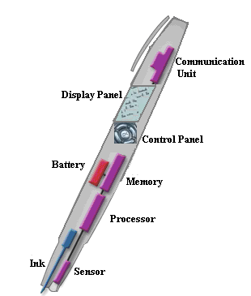

Fig: 2.1 Smart Note Taker interior structure

How does it work?
 |  | 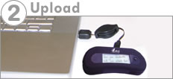 |  | 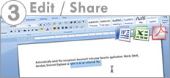
Simply write your notes with the provided standard ink pen  The pen is wireless, use it everywhere. |  | When you are back to your computer, simply upload your notes!  You can also write when connected. |  | Using the provided software suite, all your notes will be converted into editable texts!  Edit your notes in your favorite software!

Fig: 2.1.1 Working of a Smart Note Taker.

2.2. TECHNICAL DEFINITION OF THE PRODUCT

In order to meet the technical requirements of the product we need Operating System Like Windows or Linux in order to implement software part of the project, displacement sensors to recognize the displacement of the pen in three dimensions, parallel cable to communicate with computer, software to solve the displacement data and to find the individual coordinate displacement in three axes and transform the data into text format, analog to digital converter to process analog displacement data and convert them into digital format, switch to control the pen and Rechargeable battery.

- Operating System
- Software program to convert data into text or string format
- Displacement Sensor
- Parallel cable
- Analog to digital converter
- Switch
- Rechargeable battery

2.3. OPPORTUNITIES IN THE MARKET

In the current market there are many similar products that can convert handwritten documents into digital type documents. In these products, optical sensors are being widely used to perceive the motion. Ink is also used in these products to be functioned as an ordinary pen. There are optical sensors on the pen. However, they have some lacks and imperfections such as being wired, limited in work space, non-practical and limited in 2D.

2.3.1 Treats in the Market

Companies have succeeded to make similar products and put them in the market. Putting a newly invented, innovative product in the market is not easy. The prices in the market should be well observed for similar products. The prices of 2-D digital pens are about 50 dollars to 90 dollars. The new product is 3-D Smart Note Taker that has a memory chip on it in addition to the features that the previous pens have.

2.4. SMART NOTETAKER’S
CONSUMER PROFILE AND PURCHASE POWER

Smart note taker is incompatible among the other products. It has some significant differences from its potential competitors. This plays a crucial role in the marketing strategy and attractiveness of product in the segmented mark.

The prior market is educational services and schools. In today’s fast and information based life; the faster and easier you get information, the more successful you can be. The customers are going to be teachers generally and students indirectly. While lecturing the usage on the board for teachers and note-taking for students cause dilute of time and sometimes embarrassing.

In order to utilitize the time and to grasp more attention of students smart note taker is a great solution, which transfers the notes of the teacher on the board to software directly. It optimizes efficiency of time that is used during the lecturing and it is desirable for the educational.

3. ADVANTAGES
- With the help of smart note taker we can write notes on any surface even in air. That is we can write notes any time without using a paper. So we can get information in very fast and easy way. Hence it is time saving.
- Smart note taker is reliable and powerful.
- It is helpful for blind who can’t see but can think and write freely.
- Smart note taker is used by the instructors while giving presentations.
- It is used along with paint and JAVA graphics and so this product is compatible with all graphics software.
- Easy-to-use wireless connection.
- Drawer (Contents outline, library, history).

4. CURRENT PRODUCTS

4.1. MOBILE NOTE TAKER
The Ultimate Handwriting Capture Device Mobile NoteTakerTM is the world’s first portable handwriting capture device based on natural handwriting as an input. Attach plain paper of any kind and use Pegasus the electronic pen to capture, store and share handwritten drawings, sketches, notes, and memos at meetings, lectures, and conferences.

Mobile NoteTakerTM has a built-in LCD to confirm input. The on-board flash memory can store up to 50 pages (size A4).

Mobile Note Taker works in two modes :- mobile mode and Connected mode .In mobile mode note taker receiver unit is not connected to a PC via USB cable. In connected mode the base unit is connected to a PC through USB cable.

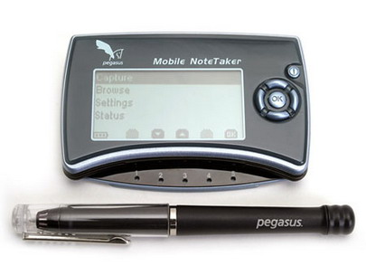
Fig: 4.1 Mobile Note Taker

4.2. PC NOTE TAKER

PC Notes Taker is the world's first device that captures natural handwriting on any surface onto a PC in real time. Based on a revolutionary electronic pen, PC Notes Taker displays the user's handwritten notes, memos or drawings on the computer, and stores the image for future use. PC Notes Taker is ideal for markets where handwritten input is essential, such as health, educational and financial sectors. Supplied with user-friendly software, PC Notes Taker is compatible with PCs and notebooks.

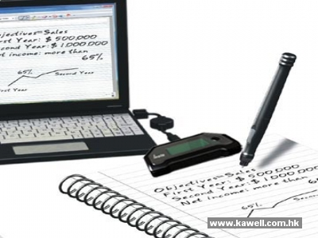

Fig: 4.2 PC Note Take

5. FUTURE SCOPE

Companies have succeeded to make similar products and put them in the market. Putting a newly invented, innovative product in the market is not easy. The prices in the market should be well observed for similar products. The prices of 2-D digital pens are about 50 dollars to 90 dollars. So the price of smart note taker will be high. But this disadvantage can be definitely eliminated in near future.

6. CONCLUSION

This system tries to improve a pen, which helps people get rid of typing problems on computer by the technology, which converts your handwriting to text format on your PC.

It can also be used like all other classical pens. Therefore, this device will increase the capacity of noting the texts, lessons and projects you work on

Hence it can be concluded that the smart note taker is a device that can store visual recordings and thus can be used widely.

7. REFERENCES

- http:/www.wikipedia.com
- http://www.newscientist.com
- http://fp.uni.edu/its/et/studioit/smartboard.htm
- http://www.campus-technology.com
- http://www2.smarttech.com/st/enUS/Products/Interactive+Pen+Displays
- http://www.ipen4you.com
- http://ge402.bilkent.edu.trs
- http://www.pegatech.com
- http://www.cnn.com

